FINAL IMPLEMENTATION
STEP 1: IMPORTING DATA
import os
import random
import shutil
from PIL import Image

import os

base_dir = r"D:\Datasets\Indian Medicinal Leaves Image Datasets"

# Walk through all subfolders and print first 10 image paths
image_count = 0
for root, dirs, files in os.walk(base_dir):
for file in files:
if file.lower().endswith((".jpg", ".jpeg", ".png")):
image_count += 1
print(os.path.join(root, file))
if image_count >= 10:
break
if image_count >= 10:
break

print(f"\nTotal images found (first 10 shown): {image_count}")

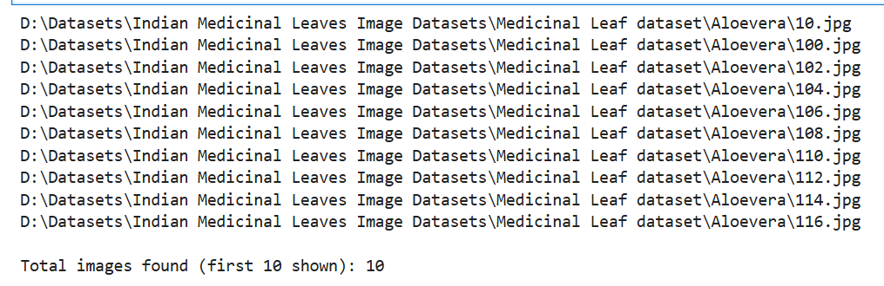
STEP 2: DATA CLEANING
import os
from PIL import Image

def remove_corrupted_images_in_batches(base_dir, batch_size=100):
total_checked = 0
total_removed = 0
batch_counter = 0

for root, dirs, files in os.walk(base_dir):
for file in files:
if file.lower().endswith((".jpg", ".jpeg", ".png")):
total_checked += 1
batch_counter += 1
img_path = os.path.join(root, file)
try:
img = Image.open(img_path)
img.verify()
except (IOError, SyntaxError):
print(f"Removed corrupted image: {img_path}")
os.remove(img_path)
total_removed += 1

# Print progress after each batch
if batch_counter >= batch_size:
print(f"Checked {total_checked} images so far, removed {total_removed} corrupted images")
batch_counter = 0 # reset batch counter

print(f"\nCleaning completed!")
print(f"Total images checked: {total_checked}")
print(f"Total corrupted images removed: {total_removed}")

# Usage
base_dir = r"D:\Datasets\Indian Medicinal Leaves Image Datasets\Medicinal Leaf dataset"
remove_corrupted_images_in_batches(base_dir, batch_size=100)

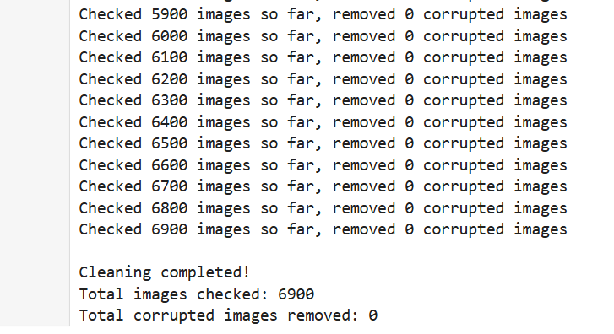

STEP 3: COMBINING ALL THE DATA SET IN A SINGLE FILE
import os
import shutil

# Source folder (your cleaned dataset)
source_dir = r"D:\Datasets\Indian Medicinal Leaves Image Datasets\Medicinal Leaf dataset"

# Target folder
target_dir = r"D:\Datasets\Dataset_Ready"

# Create target folder if it doesn't exist
os.makedirs(target_dir, exist_ok=True)

# Walk through all plant folders
for root, dirs, files in os.walk(source_dir):
for folder in dirs:
class_name = folder
class_src = os.path.join(root, folder)
class_dst = os.path.join(target_dir, class_name)
os.makedirs(class_dst, exist_ok=True)

# Copy all images from this folder to the class folder in target
for file in os.listdir(class_src):
if file.lower().endswith((".jpg", ".jpeg", ".png")):
src_file = os.path.join(class_src, file)
dst_file = os.path.join(class_dst, file)
shutil.copy2(src_file, dst_file)

print("All images have been combined into Dataset_Ready!")

All images have been combined into Dataset_Ready!

STEP 4: IMAGE / DATA PREPROCESSING
from torchvision import transforms
from torchvision.datasets import ImageFolder
from torch.utils.data import DataLoader

# Define transforms
train_transforms = transforms.Compose([
transforms.Resize((224, 224)), # Resize images
transforms.RandomHorizontalFlip(), # Data augmentation
transforms.ToTensor(), # Convert to tensor
transforms.Normalize( # Normalize for ResNet-50
mean=[0.485, 0.456, 0.406],
std=[0.229, 0.224, 0.225]
)
])

val_transforms = transforms.Compose([
transforms.Resize((224, 224)),
transforms.ToTensor(),
transforms.Normalize(
mean=[0.485, 0.456, 0.406],
std=[0.229, 0.224, 0.225]
)
])

import torch
import torchvision

print(torch.__version__)
print(torchvision.__version__)
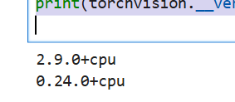

from torchvision import transforms
from torchvision.datasets import ImageFolder
from torch.utils.data import DataLoader, random_split

# Define transforms
train_transforms = transforms.Compose([
transforms.Resize((224, 224)),
transforms.RandomHorizontalFlip(), # optional augmentation
transforms.ToTensor(),
transforms.Normalize(
mean=[0.485, 0.456, 0.406],
std=[0.229, 0.224, 0.225]
)
])

val_transforms = transforms.Compose([
transforms.Resize((224, 224)),
transforms.ToTensor(),
transforms.Normalize(
mean=[0.485, 0.456, 0.406],
std=[0.229, 0.224, 0.225]
)
])

# Load dataset
dataset_path = r"D:\Datasets\Dataset_Ready"
dataset = ImageFolder(root=dataset_path, transform=train_transforms)

STEP 5: SPLITTING TRAINING AND TEST SET
# Split into train and validation (80-20)
train_size = int(0.8 * len(dataset))
val_size = len(dataset) - train_size
train_dataset, val_dataset = random_split(dataset, [train_size, val_size])

# Create DataLoaders
train_loader = DataLoader(train_dataset, batch_size=32, shuffle=True)
val_loader = DataLoader(val_dataset, batch_size=32, shuffle=False)

print(f"Training samples: {len(train_dataset)}, Validation samples: {len(val_dataset)}")

Step 6: Loading Resnet 50
import torch
import torch.nn as nn
from torchvision import models

# Load pretrained ResNet-50
model = models.resnet50(weights=models.ResNet50_Weights.DEFAULT)

# Number of classes (number of plant types)
num_classes = len(dataset.classes) # this automatically detects your folders

# Replace the final fully connected layer
model.fc = nn.Linear(model.fc.in_features, num_classes)

print(model)

import torch.optim as optim

# Use GPU if available
device = torch.device("cuda" if torch.cuda.is_available() else "cpu")
model = model.to(device)

# Loss function
criterion = nn.CrossEntropyLoss()

# Optimizer
optimizer = optim.Adam(model.parameters(), lr=0.001)

from torchvision import models

device = torch.device("cuda" if torch.cuda.is_available() else "cpu")

model = models.resnet50(pretrained=True)
num_classes = 80
model.fc = nn.Linear(model.fc.in_features, num_classes)
model = model.to(device)

import torch
torch.serialization.add_safe_globals([torch.nn.modules.loss.CrossEntropyLoss])

checkpoint = torch.load('medicinal_model_checkpoint.pth', map_location=device)
model.load_state_dict(checkpoint['model_state_dict'])
optimizer.load_state_dict(checkpoint['optimizer_state_dict'])
start_epoch = checkpoint['epoch'] + 1
print(f"✅ Resuming training from epoch {start_epoch}")

STEP 7: TRAINING THE DATA SET
for epoch in range(start_epoch, num_epochs):
model.train()
running_loss = 0.0
correct_train = 0
total_train = 0

train_loader_tqdm = tqdm(train_loader, desc=f"Epoch {epoch+1}/{num_epochs} [Training]", unit="batch")
for images, labels in train_loader_tqdm:
images, labels = images.to(device), labels.to(device)

optimizer.zero_grad()
outputs = model(images)
loss = criterion(outputs, labels)
loss.backward()
optimizer.step()

running_loss += loss.item()
_, predicted = torch.max(outputs.data, 1)
total_train += labels.size(0)
correct_train += (predicted == labels).sum().item()

# Calculate train metrics
train_loss = running_loss / len(train_loader)
train_acc = 100 * correct_train / total_train

# Validation
model.eval()
correct_val = 0
total_val = 0
with torch.no_grad():
val_loader_tqdm = tqdm(val_loader, desc=f"Epoch {epoch+1}/{num_epochs} [Validation]", unit="batch")
for images, labels in val_loader_tqdm:
images, labels = images.to(device), labels.to(device)
outputs = model(images)
_, predicted = torch.max(outputs.data, 1)
total_val += labels.size(0)
correct_val += (predicted == labels).sum().item()

val_acc = 100 * correct_val / total_val
print(f"Epoch [{epoch+1}/{num_epochs}] -> Train Loss: {train_loss:.4f}, Train Acc: {train_acc:.4f}, Val Acc: {val_acc:.4f}")

# ✅ Save checkpoint after each epoch
torch.save({
'epoch': epoch,
'model_state_dict': model.state_dict(),
'optimizer_state_dict': optimizer.state_dict(),
'loss': loss
}, 'medicinal_model_checkpoint.pth')

print(f"✅ Checkpoint saved at epoch {epoch+1}")

torch.save(model.state_dict(), 'medicinal_model_final.pth')
import torch
from sklearn.metrics import confusion_matrix
import numpy as np
from tqdm import tqdm # classic tqdm, works in notebooks too
import sys

# Load model checkpoint
checkpoint = torch.load('medicinal_model_checkpoint.pth', map_location=device)
model.load_state_dict(checkpoint['model_state_dict'])
model.eval()

all_preds = []
all_labels = []

# Validation loop with live progress
for batch_idx, (images, labels) in enumerate(tqdm(val_loader, desc="Validating", unit="batch"), 1):
images, labels = images.to(device), labels.to(device)
with torch.no_grad():
outputs = model(images)
_, preds = torch.max(outputs, 1)

all_preds.extend(preds.cpu().numpy())
all_labels.extend(labels.cpu().numpy())

# Print cumulative batch info
batch_acc = (preds == labels).sum().item() / labels.size(0)
print(f"Batch {batch_idx}/{len(val_loader)}, Batch Acc: {batch_acc:.4f}, Processed: {batch_idx*labels.size(0)}/{len(val_dataset)}")
sys.stdout.flush() # force immediate print

# Metrics
accuracy = np.mean(np.array(all_preds) == np.array(all_labels))
print(f"\n✅ Validation Accuracy: {accuracy*100:.2f}%")

# Confusion Matrix
cm = confusion_matrix(all_labels, all_preds)
print("\nConfusion Matrix:")
print(cm)

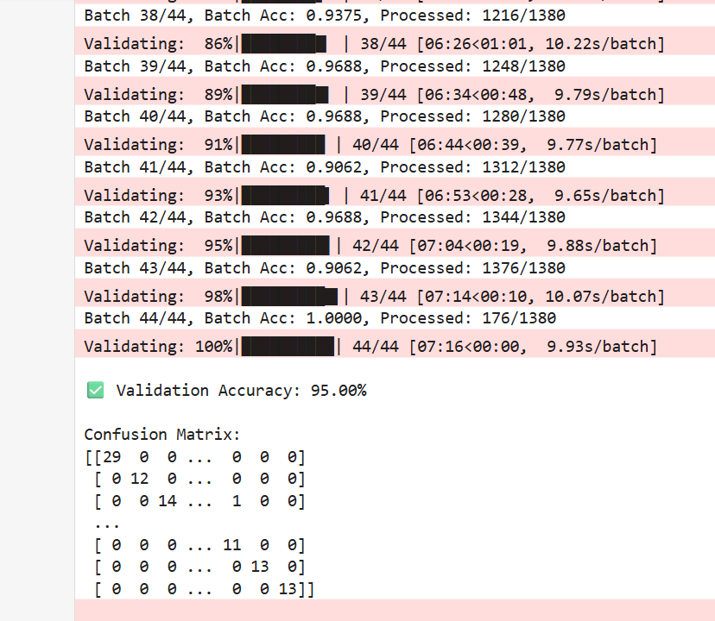

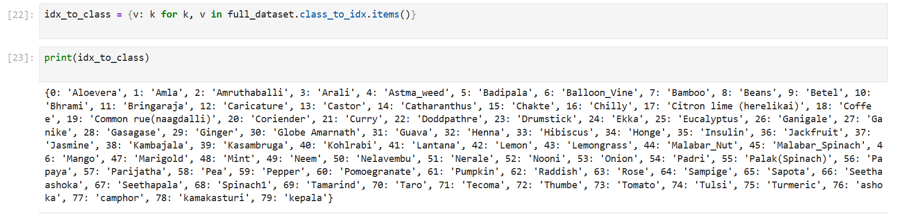

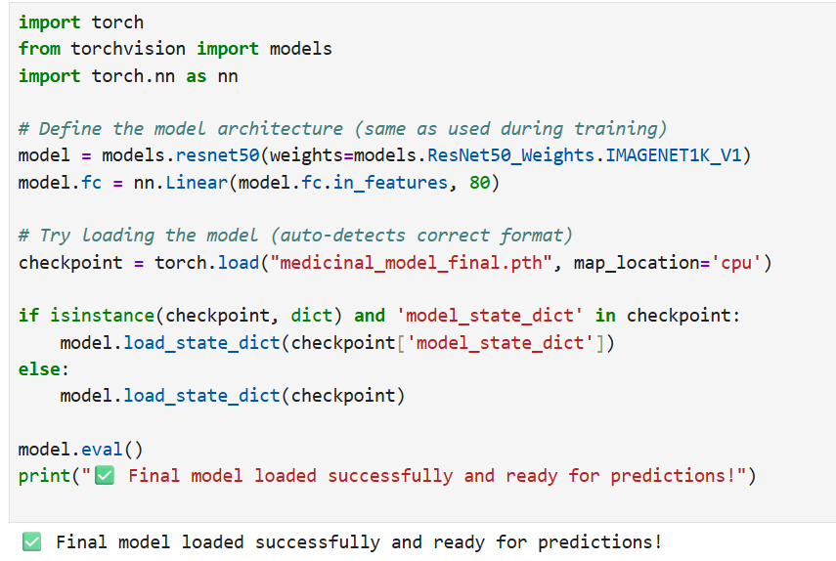

Plant dictionary

plant_info = {
"Aloevera": {
"properties": "Anti-inflammatory, antibacterial, antioxidant, and skin healing agent.",
"uses": "Used for treating burns, wounds, acne, and improving skin health."
},
"Amla": {
"properties": "Rich in Vitamin C and antioxidants.",
"uses": "Boosts immunity, improves digestion, promotes hair growth."
},
"Amruthaballi": {
"properties": "Immunomodulatory and anti-diabetic.",
"uses": "Used for fever, diabetes, and to enhance body immunity."
},
"Arali": {
"properties": "Antibacterial and anti-inflammatory.",
"uses": "Used externally for skin diseases and inflammation."
},
"Astma_weed": {
"properties": "Antiasthmatic, anti-inflammatory.",
"uses": "Traditionally used for asthma, bronchitis, and cough relief."
},
"Badipala": {
"properties": "Anthelmintic and anti-inflammatory.",
"uses": "Used in traditional medicine to expel intestinal worms."
},
"Balloon_Vine": {
"properties": "Anti-arthritic and anti-inflammatory.",
"uses": "Used for joint pain, arthritis, and skin ailments."
},
"Bamboo": {
"properties": "Rich in silica and antioxidants.",
"uses": "Used for bone strength, wound healing, and respiratory issues."
},
"Beans": {
"properties": "Rich in proteins, fiber, and antioxidants.",
"uses": "Improves digestion, supports heart health, and manages cholesterol."
},
"Betel": {
"properties": "Antiseptic and digestive stimulant.",
"uses": "Used for oral health, digestion, and respiratory problems."
},
"Bhrami": {
"properties": "Memory enhancer, antioxidant, anti-anxiety.",
"uses": "Used to improve memory, concentration, and reduce stress."
},
"Bringaraja": {
"properties": "Hair tonic and liver protector.",
"uses": "Used for promoting hair growth and treating liver disorders."
},
"Caricature": {
"properties": "Anti-inflammatory and antipyretic.",
"uses": "Used for fever, pain, and inflammation in traditional remedies."
},
"Castor": {
"properties": "Laxative, anti-inflammatory, and antimicrobial.",
"uses": "Used for constipation, joint pain, and hair nourishment."
},
"Catharanthus": {
"properties": "Anticancer and antidiabetic.",
"uses": "Used in formulations for leukemia and diabetes control."
},
"Chakte": {
"properties": "Antioxidant and anti-inflammatory.",
"uses": "Used for treating wounds and infections in folk medicine."
},
"Chilly": {
"properties": "Rich in capsaicin; analgesic and antioxidant.",
"uses": "Used for pain relief and improving metabolism."
},
"Citron lime (herelikai)": {
"properties": "Antioxidant and vitamin-rich.",
"uses": "Used to improve digestion and immunity."
},
"Coffee": {
"properties": "Antioxidant and stimulant.",
"uses": "Improves alertness and helps reduce fatigue."
},
"Common rue(naagdalli)": {
"properties": "Antispasmodic and antibacterial.",
"uses": "Used for digestive and menstrual issues."
},
"Coriender": {
"properties": "Digestive, anti-inflammatory, and cooling.",
"uses": "Used to treat acidity, improve digestion, and detoxify body."
},
"Curry": {
"properties": "Rich in antioxidants and vitamins.",
"uses": "Used to promote hair growth and improve eyesight."
},
"Doddpathre": {
"properties": "Antiseptic, antimicrobial, and expectorant.",
"uses": "Used for cold, cough, and throat infections."
},
"Drumstick": {
"properties": "Rich in iron and vitamins; anti-inflammatory.",
"uses": "Used for anemia, joint pain, and boosting immunity."
},
"Ekka": {
"properties": "Antispasmodic and anti-inflammatory.",
"uses": "Used for asthma, skin diseases, and digestive issues."
},
"Eucalyptus": {
"properties": "Antiseptic, antibacterial, and expectorant.",
"uses": "Used for cough, cold, and respiratory infections."
},
"Ganigale": {
"properties": "Anti-inflammatory and digestive aid.",
"uses": "Used in traditional remedies for fever and body pain."
},
"Ganike": {
"properties": "Antioxidant and antimicrobial.",
"uses": "Used for wound healing and improving digestion."
},
"Gasagase": {
"properties": "Sedative and pain-relieving.",
"uses": "Used to induce sleep and reduce body heat."
},
"Ginger": {
"properties": "Anti-inflammatory and antioxidant.",
"uses": "Used for nausea, cold, cough, and digestion."
},
"Globe Amarnath": {
"properties": "Antioxidant and anti-inflammatory.",
"uses": "Used for respiratory issues and to cool the body."
},
"Guava": {
"properties": "Antimicrobial and vitamin-rich.",
"uses": "Used for diarrhea, diabetes, and boosting immunity."
},
"Henna": {
"properties": "Cooling, antifungal, and antimicrobial.",
"uses": "Used for hair conditioning and skin cooling."
},
"Hibiscus": {
"properties": "Antioxidant and hair tonic.",
"uses": "Used for promoting hair growth and controlling blood pressure."
},
"Honge": {
"properties": "Antimicrobial and insecticidal.",
"uses": "Used in treating skin infections and wounds."
},
"Insulin": {
"properties": "Antidiabetic and antioxidant.",
"uses": "Used to reduce blood sugar levels naturally."
},
"Jackfruit": {
"properties": "Rich in fiber and antioxidants.",
"uses": "Used for digestion and as an energy booster."
},
"Jasmine": {
"properties": "Antidepressant and soothing aroma.",
"uses": "Used in aromatherapy and skincare."
},
"Kambajala": {
"properties": "Anti-inflammatory and antimicrobial.",
"uses": "Used for skin and throat infections."
},
"Kasambruga": {
"properties": "Anti-inflammatory and cooling.",
"uses": "Used for treating fever and headaches."
},
"Kohlrabi": {
"properties": "Rich in vitamins and fiber.",
"uses": "Supports digestion and immunity."
},
"Lantana": {
"properties": "Antimicrobial and wound healing.",
"uses": "Used for treating cuts, wounds, and skin infections."
},
"Lemon": {
"properties": "Rich in Vitamin C and antioxidants.",
"uses": "Boosts immunity and aids digestion."
},
"Lemongrass": {
"properties": "Antibacterial and anti-anxiety.",
"uses": "Used for stress relief and digestion."
},
"Malabar_Nut": {
"properties": "Antitussive and expectorant.",
"uses": "Used for treating cough and asthma."
},
"Malabar_Spinach": {
"properties": "Rich in iron and vitamins.",
"uses": "Used for anemia and improving skin glow."
},
"Mango": {
"properties": "Antioxidant and vitamin-rich.",
"uses": "Used for improving digestion and immunity."
},
"Marigold": {
"properties": "Antiseptic and anti-inflammatory.",
"uses": "Used for wound healing and skin care."
},
"Mint": {
"properties": "Cooling and digestive.",
"uses": "Used for nausea, cold, and indigestion."
},
"Neem": {
"properties": "Antibacterial, antifungal, and antiviral.",
"uses": "Used for acne, skin disorders, and blood purification."
},
"Nelavembu": {
"properties": "Antiviral and immunomodulatory.",
"uses": "Used for fever, malaria, and immune support."
},
"Nerale": {
"properties": "Antidiabetic and antioxidant.",
"uses": "Used for controlling blood sugar and digestion."
},
"Nooni": {
"properties": "Anti-inflammatory and antioxidant.",
"uses": "Used for boosting immunity and energy."
},
"Onion": {
"properties": "Antimicrobial and anti-inflammatory.",
"uses": "Used for cough, cold, and heart health."
},
"Padri": {
"properties": "Antioxidant and antimicrobial.",
"uses": "Used for treating infections and inflammation."
},
"Palak(Spinach)": {
"properties": "Rich in iron and folate.",
"uses": "Used for anemia and improving vision."
},
"Papaya": {
"properties": "Digestive enzyme papain; antioxidant.",
"uses": "Used for digestion and skin health."
},
"Parijatha": {
"properties": "Antipyretic and anti-inflammatory.",
"uses": "Used for fever and body pain."
},
"Pea": {
"properties": "Rich in protein and fiber.",
"uses": "Used for digestion and heart health."
},
"Pepper": {
"properties": "Antioxidant and antimicrobial.",
"uses": "Used for cough, cold, and digestion."
},
"Pomoegranate": {
"properties": "Antioxidant and anti-inflammatory.",
"uses": "Used for heart health and immunity."
},
"Pumpkin": {
"properties": "Rich in beta-carotene and antioxidants.",
"uses": "Used for eye health and digestion."
},
"Raddish": {
"properties": "Antioxidant and detoxifying.",
"uses": "Used for liver health and digestion."
},
"Rose": {
"properties": "Cooling and antioxidant.",
"uses": "Used for skincare and aromatherapy."
},
"Sampige": {
"properties": "Aromatic and antimicrobial.",
"uses": "Used for perfume and relaxation."
},
"Sapota": {
"properties": "Rich in fiber and vitamins.",
"uses": "Used for digestion and energy."
},
"Seethaashoka": {
"properties": "Anti-inflammatory and uterine tonic.",
"uses": "Used for menstrual disorders and pain relief."
},
"Seethapala": {
"properties": "Antioxidant and anti-inflammatory.",
"uses": "Used for digestion and anemia."
},
"Spinach1": {
"properties": "Rich in iron and vitamins.",
"uses": "Used for improving hemoglobin and eyesight."
},
"Tamarind": {
"properties": "Rich in tartaric acid and antioxidants.",
"uses": "Used for digestion and cooling effect."
},
"Taro": {
"properties": "Rich in starch and fiber.",
"uses": "Used for digestion and energy supply."
},
"Tecoma": {
"properties": "Antidiabetic and antimicrobial.",
"uses": "Used for controlling blood sugar levels."
},
"Thumbe": {
"properties": "Anti-inflammatory and antiseptic.",
"uses": "Used for wounds and respiratory problems."
},
"Tomato": {
"properties": "Rich in lycopene and antioxidants.",
"uses": "Used for heart health and skin care."
},
"Tulsi": {
"properties": "Antibacterial, antiviral, and antioxidant.",
"uses": "Used for cough, cold, and boosting immunity."
},
"Turmeric": {
"properties": "Anti-inflammatory and antioxidant (curcumin).",
"uses": "Used for wounds, immunity, and pain relief."
},
"ashoka": {
"properties": "Anti-inflammatory and uterine tonic.",
"uses": "Used for menstrual disorders and reproductive health."
},
"camphor": {
"properties": "Antiseptic and analgesic.",
"uses": "Used for pain relief and as a decongestant."
},
"kamakasturi": {
"properties": "Aromatic and antispasmodic.",
"uses": "Used for perfume and stress relief."
},
"kepala": {
"properties": "Antioxidant and antimicrobial.",
"uses": "Used for treating infections and improving immunity."
}
}
import torch
from torchvision import transforms, models
from PIL import Image
import os
from plant_info import plant_info

# --- Step 1: Paths ---
model_path = r"C:\Users\Dell\MedicinalPlantDetection\medicinal_model_final.pth"
test_image_path = r"C:\Users\Dell\MedicinalPlantDetection\test_images\tulsi_sample.jpg"

# --- Step 2: Check paths ---
if not os.path.exists(model_path):
print(f"❌ Model not found at: {model_path}")
elif not os.path.exists(test_image_path):
print(f"❌ Test image not found at: {test_image_path}")
else:
print(f"✅ Model and image found!\n{model_path}\n{test_image_path}")

# --- Step 3: Load correct model architecture ---
model = models.resnet50(weights=None) # ✅ change here from resnet18 to resnet50
model.fc = torch.nn.Linear(model.fc.in_features, len(plant_info)) # final layer for your number of plants

# --- Step 4: Load trained weights ---
state_dict = torch.load(model_path, map_location=torch.device('cpu'))
model.load_state_dict(state_dict)
model.eval()

# --- Step 5: Preprocess image ---
transform = transforms.Compose([
transforms.Resize((224, 224)),
transforms.ToTensor(),
transforms.Normalize([0.485, 0.456, 0.406],
[0.229, 0.224, 0.225])
])

image = Image.open(test_image_path).convert("RGB")
image_tensor = transform(image).unsqueeze(0)

# --- Step 6: Predict ---
with torch.no_grad():
outputs = model(image_tensor)
_, predicted = torch.max(outputs, 1)

# --- Step 7: Map prediction ---
class_names = list(plant_info.keys())
predicted_plant = class_names[predicted.item()]

# --- Step 8: Display info ---
info = plant_info.get(predicted_plant, {"properties": "N/A", "uses": "N/A"})

print("\n🌿 Predicted Medicinal Plant:")
print(f" 🔹 Name: {predicted_plant}")
print(f" 🧪 Properties: {info['properties']}")
print(f" 💊 Uses: {info['uses']}")

